**Exercise 3 : Assertions in JUnit**

**Key Points:**

* **JUnit 5 Imports:**
  + **@Test** is used to mark the method as a test case.
  + Static imports from **org.junit.jupiter.api.Assertions** provide assertion methods.

**Assertions Used:**

* **assertEquals(expected, actual):**Verifies that two values are equal.
* **assertTrue(condition):**Checks that the condition is true.
* **assertFalse(condition):**Checks that the condition is false.
* **assertNull(object):**Asserts that the object is null.
* **assertNotNull(object):**Asserts that the object is not null.

Example Test Method:

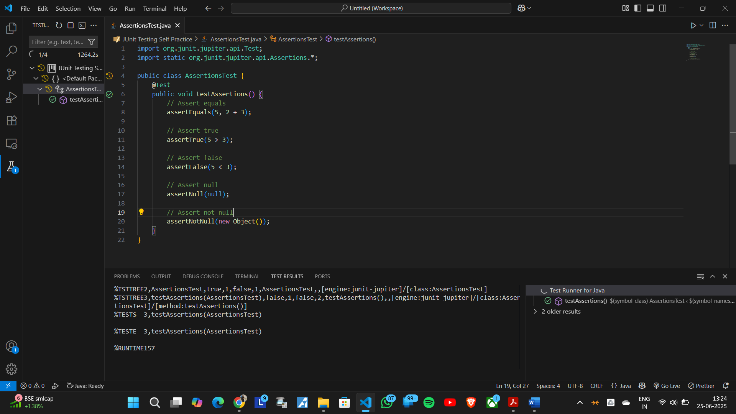The testAssertions() method demonstrates all the above assertions with simple examples.